Name:
Evaluate the following limits as delineated: Date:

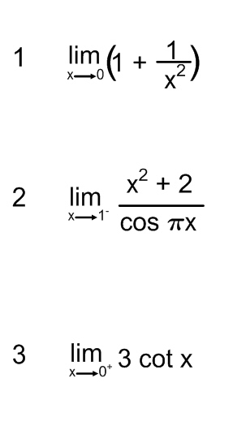

Find the vertical asymptotes of the following functions:
