Name:
For what values of x is the function f(x) continuous: Date:
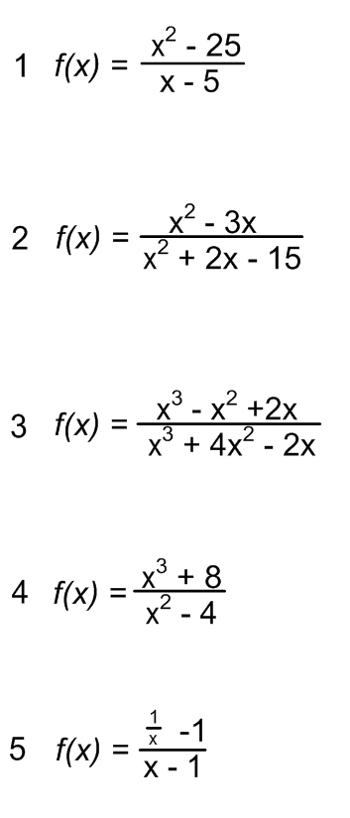

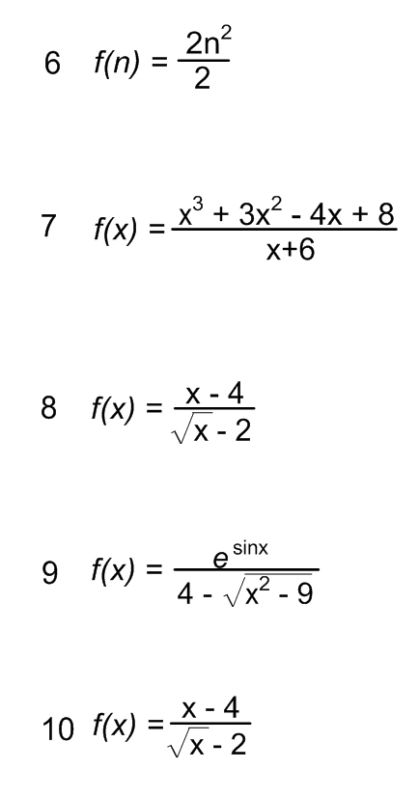

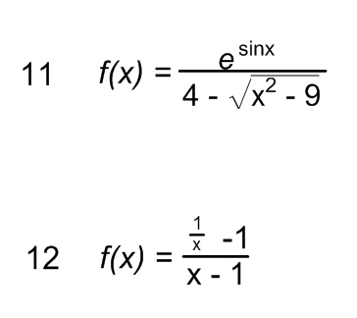

Below create up to three different limits of your own as a pool for test/quiz questions. Each must have a solution and/or explanation as a solutions manual to verify the validity of the problem (bonus points for each):

