Name:
Evaluate the following limits as delineated: Date:
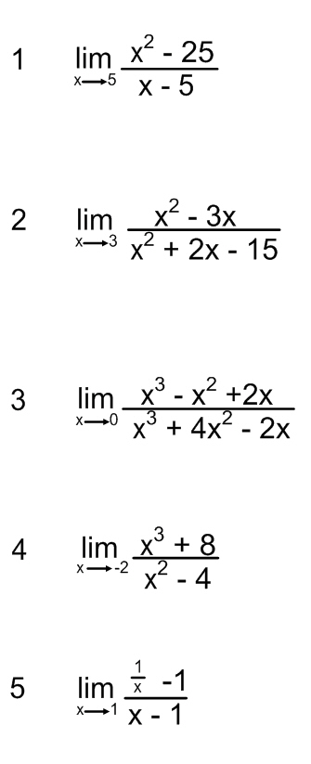

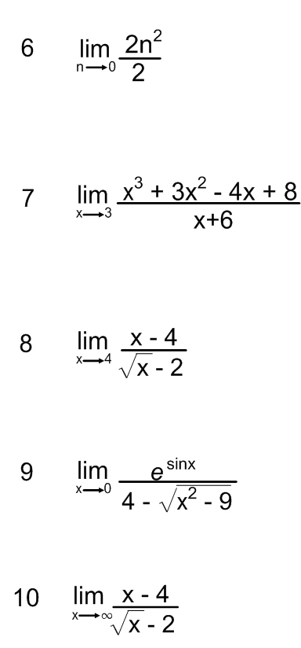

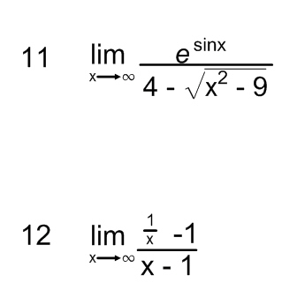

Below create up to three different limits of your own as a pool for test/quiz questions. Each must have a solution and/or explanation as a solutions manual to verify the validity of the problem (bonus points for each):

