Find the Extrema:
- $f\left(x\right)= \frac{3}{x-1}$ [-2,2]

- $f\left(x\right)= x^{2}-5$ [-3,3]

Determine if Rolle’s Theorem applies, if so find the values of c such that $f^{'}\left(c\right)= 0$
- $f\left(x\right)= x^{2}-2x$ [0,2]

- $f\left(x\right)= x^{2}-5x+4$ [1,4]

Using the mean value theorem, find all the values of c such that: $f'\left(c\right)=\frac{F(b)-f(a)}{b-a}$
- $f\left(x\right)=x(x^{2}-x-2)$ [-1,1]

Using the first derivative test find all intervals and determine if they are increasing or decreasing. Find all critical points and extrema. Label critical points as to whether they are a max, min, or vertical asymptote.
- $f\left(x\right)=\frac{x^{2}}{(x^{2}-9)}$ [-5,5]

- Label the intervals and determine whether they are increasing or decreasing:
Circle the appropriate answers:

Interval A: increasing decreasing
Interval B: increasing decreasing
Interval C: increasing decreasing

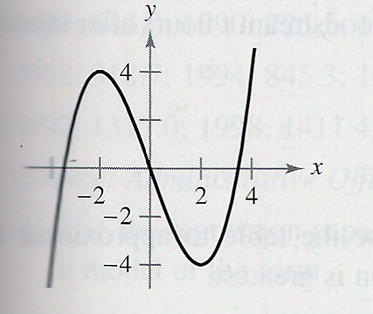
( , )( , )( , )
int A int B int C

- Explain the difference between Rolle’s Theorem and the Mean Value Theorem. How do you decide when which applies? What is the difference between the f ’(c) over the interval (a,b) that you find using the two theorems? What can you tell me about the secant and tangent used in these theorems?

