- Find the Limit of the following, if it exists. Show all work required to simplify and or justify your answer.
$$\lim_{x→3}{{\left(\frac{4x^{3}+4x^{2}-48x}{\left(x^{2}-2x\right)(x^{2}-9)}\right)}^{ }}$$

- Find the vertical asymptotes of the following function:
$$\lim_{x→3}{{\left(\frac{4x^{3}+4x^{2}-24x}{\left(x^{2}-2x\right)(x^{2}-9)}\right)}^{ }}$$

- Is the following function continuous over the interval [-3, 4]? If not show the values for x where point(s) of discontinuity exist.
$$f(x)=\frac{x^{2}+x+1}{x^{3}-1}$$

In this section, find the derivatives of the following functions. Label which rule was used for each case in the blank provided. Write your derivative answer in the indicated space to the left for each case.

- Rule:_________________
$$f\left(x\right)=x^{2}+5-3x^{-2}$$
$$\frac{df}{dx}=$$

- Rule:_________________
$$t\left(x\right)=2+3cosx$$
$$\frac{dt}{dx}=$$

- Rule:_________________
$$y={3x}^{5}(6x-5x^{2})$$
$$\frac{dy}{dx}=$$

- Rule:_________________
$$g\left(x\right)=\frac{{2x}^{2}-3x-1}{x}$$
$$\frac{dg}{dx}=$$

- Rule:_________________
$$h\left(x\right)={(x}^{2}+5)(9x^{5}-3x^{-2})$$
$$\frac{dh}{dx}=$$

- Rule:_________________
$$f\left(x\right)={\left(x^{5}-3x^{2}+5\right)}^{4}$$
$$\frac{df}{dx}=$$

- Rule:_________________
$$m\left(x\right)={sin\left(x^{4}-3\right)}^{ }$$
$$\frac{dm}{dx}=$$

- Rule:_________________
$$p\left(x\right)={sin\left(cosx^{9}\right)}^{ }$$
$$\frac{dp}{dx}=$$

- Rule:_________________
$$q\left(x\right)={(3x^{3}-2x)\left(x^{3}+5\right)}^{4}$$
$$\frac{dq}{dx}=$$

- Rule:_________________
$$g\left(x\right)=\frac{{\left(x^{4}-3x^{2}+5\right)}^{4}}{sinx^{2}}$$
$$\frac{dg}{dx}=$$

- Rule:_________________
$$μ\left(x\right)=πx^{5}-θx^{3}+ωx-β$$
$$\frac{dμ}{dx}=$$

- Rule:_________________
$$v\left(x\right)={ln\left(x^{3}-7x^{2}\right)}^{ }$$
$$\frac{dv}{dx}=$$

- Rule:_________________
$$k\left(x\right)={e^{3x}}^{4}$$
$$\frac{dk}{dx}=$$

In this section, use implicit differentiations find the derivatives of the following functions as directed. Box your final answer.

- $\frac{d}{dx}\left(a^{2}+b^{2}=c^{2}\right)$

- $\frac{d}{dt}\left(V=lwh\right)$

- $\frac{d}{dt}\left(V=\frac{4}{3}πr^{3}+πr^{2}h\right)$

- $\frac{d}{dz}\left({6x^{2}e}^{5x}\right)$

- $\frac{d}{dy}\left(\frac{sinθ}{cosθ}\right)$

In this section, use implicit differentiations find the derivatives of the following functions as directed. Solve each expression and simplify your answers for the derivative indicated by the answer prompt to the left. Write and box your final answer in the indicated space to the left.

- $\frac{d}{dh}\left(y=ln15q^{4}\right)$
$$\frac{dq}{dh}=$$

- $\frac{d}{dz}\left(y={3{ex}^{5}}^{ }\right)$
$$\frac{dx}{dz}=$$

- $\frac{d}{dt}\left(t= πx^{5}-θy^{3}+ωz-β\right)$
$$\frac{dz}{dt}=$$

- $\frac{d}{dh}\left(lnx^{3}=5y\right)$
$$\frac{dy}{dh}=$$

- (Hint: Use trig identities) $\frac{d}{dz}\left(y=tanθ\right)$
$$\frac{dθ}{dz}=$$

Find the extrema max and min for the following function over the indicated closed interval. Clearly label and box your final answers.
- $f\left(x\right)= x^{2}-7x+12; I=[-1, 4]$

Solve the following related rates problems as directed:
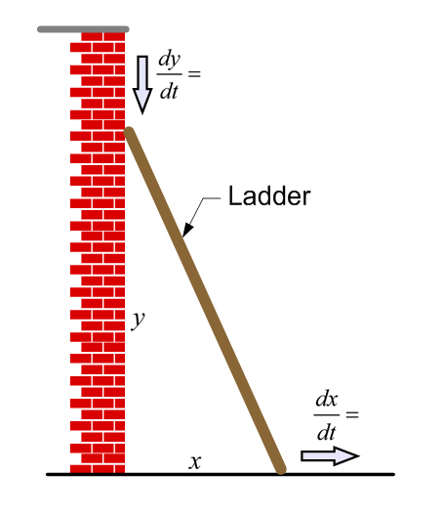
- Consider the 40 foot ladder as it leans against the side of a building as illustrated below. If the top of the ladder begins to slide down the side of the building at a constant velocity of 9.8 meters per second, how fast will the bottom of the ladder be moving to the left when the top of the ladder is 15 feet from the ground?

- In a factory there exists a conical tank (with vertex pointed downward) which has a dimension of 20 feet across and a depth of 24 feet. If solvent is flowing into the tank at a rate of 200 cubic feet per minute, find the rate of change of the depth of the water when the water is 16 feet deep.
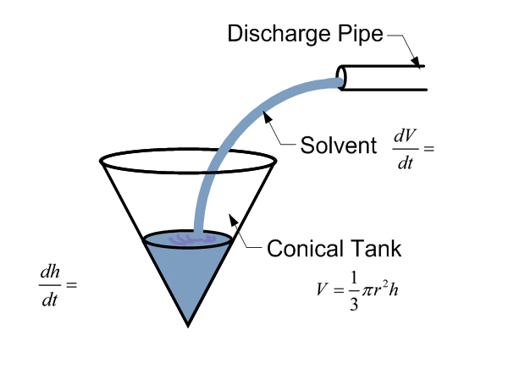

- How much solvent will the tank hold before it overflows the top?

