Part A - The use of a calculator is not allowed.
Find the derivative of each of the following functions.
- y = 6x⁵ – x + 10
- 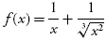
- 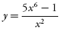
- 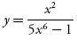
- f (x ) = (3x – 2)⁵(x² – 1)
- 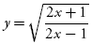
- y = 10 cot(2x – 1)
- y = 3x sec(3x)
- y = 10 cos[sin(x² – 4)]
- y = 8 cos^{–1}(2x )
- y = 3e⁵ +4xe^{x}
- y = ln(x² +3)

Part B—Calculators are allowed.
- Find , if x² + y³ =10 – 5xy.
- The graph of a function f on [1, 5] is shown in Figure 6.9–1. Find the approximate value of f '(4).
- Let f be a continuous and differentiable function. Selected values of f are shown below. Find the approximate value of f ' at x =2.
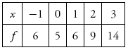
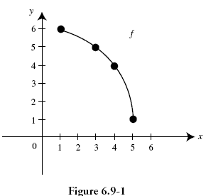
- If f (x) = x⁵ + 3x – 8, find ( f ^{–1})'(–8).
- Write an equation of the tangent to the curve y = ln x at x = e.
- If y = 2x sin x, find at x = .

- If the function f (x)=(x – 1)^{2/3} + 2, find all points where f is not differentiable.

- Write an equation of the normal line to the curve x cos y = 1 at (2, ).

- 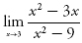

- 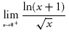

- 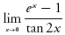

- 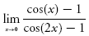

- 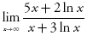

(Calculator) indicates that calculators are permitted.
- Find 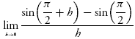.

- If f (x)= cos²(π – x ), find f '(0).

- Find 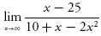.

- (Calculator) Let f be a continuous and differentiable function. Selected values of f are shown below. Find the approximate value of f ' at x = 2.
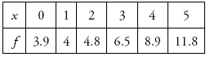
- (Calculator) If 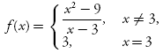 determine if f (x) is continuous at (x = 3). Explain why or why not?

