Differentiate the following.
- 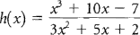
- 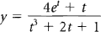
- 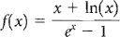
- 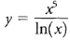
- 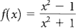
- 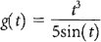
- 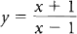
- 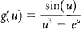
- 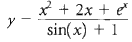
- 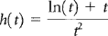
- 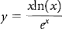
- 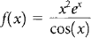
- Find the second derivative of 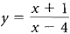
- What is the slope of the tangent line to 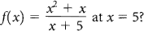
Differentiate the following.
- y = csc(x)
- y = cot(x)
- f(x) = xtan(x)
- 