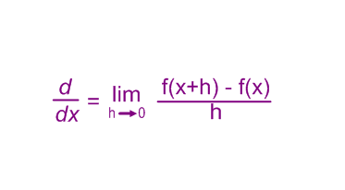
Given the formula to the right, find the derivative of the following:
- y = x²

- g(x) = x³

- v = 2

- f(x) = $\frac{1}{x}$

- z = $\frac{2}{x^{2}}$

Evaluate the limits of the following:

- lim $\frac{{(3+h)}^{2}-3^{2}}{h}$
h→0

- lim $\frac{1-x^{2}}{3x^{2}+2x-4}$
x→∞

- lim $\frac{3-14x^{5}+2x^{3}}{x^{4}-x^{5}+1}$
x→-∞

- lim $\frac{2x-15x^{3}}{14x^{2}-13x}$
x→-∞

