Name: ________________________________ Period:________ Date:_____________
Trial Time: | Calculation: | Average Time/Oscillation: | Distance X₁ | Distance X₂
seconds | / 10 = | seconds | in. | in.
Data Table:

Description:
Step 1 -
Observe Mr. Taylor’s pendulum station as he, from a fixed release point which is accurately located on the floor exactly 8 feet (X₁) from the point of rest (static equilibrium), swings the pendulum weight 10 times (back and forth counts as one swing) and times it with a stopwatch. Afterward you divide the recorded time: __________ by 10, thereby acquiring an ____________ time per swing, then input that average time you calculated: ___________ into the matrix above, along with any other pertinent information you can glean from this process.
Step 2 -
Repeat previous activity (swinging pendulum 10 full oscillations as before) but catch the pendulum at the end of the last oscillation and record the distance the pendulum arrived at by dropping a plumb bob, perpendicular to the floor, and recording that point on floor. Accurately measure (using a tape measure) the distance from this newly located point and the static equilibrium point previously discussed. X₂ = ___________
Diagram 1:
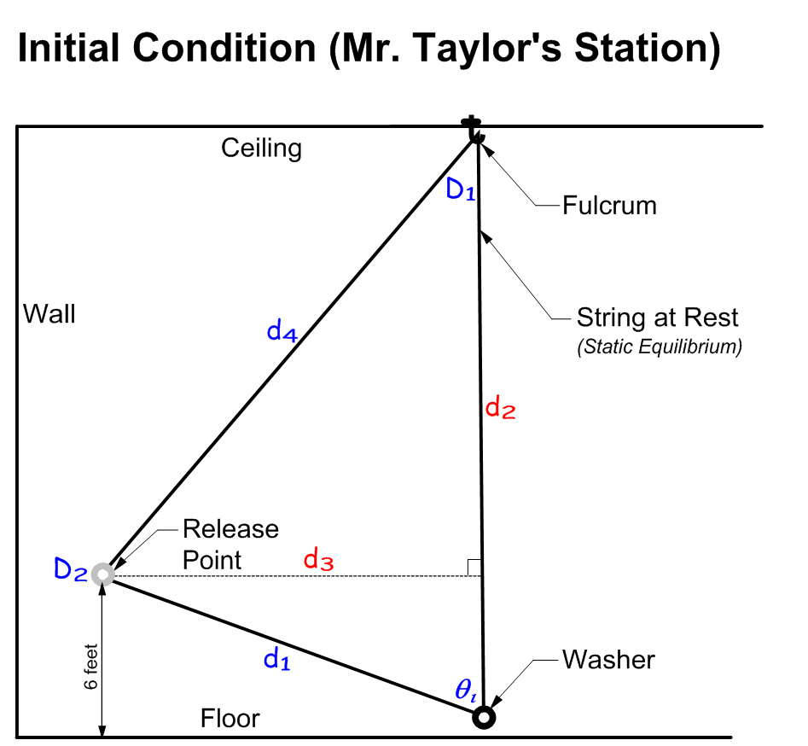
Measured Attributes:
d₂ = _______ inches
d₃ = _______ Inches
Calculated Attributes:
d₁ = _______ inches
d₄ = _______ inches
θ_{ι} = _______ degrees
D₁ = _______ degrees (at fulcrum)
D₂ = _______ degrees (at release point)
Diagram 1 Calculations:
Law of Cosine: Law of Cosine:
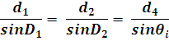(d₁)² = (d₂)² + (d₄)² – 2(d₂)(d₄)cosD₁
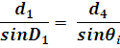( )² = ( )² + ( )² – 2( )( )cosD₁
( ) = ( ) + ( ) – 2( )( )cosD₁
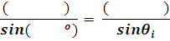( ) = ( ) – 2( )cosD₁
( ) = ( ) – ( )cosD₁
( ) = – ( )cosD₁
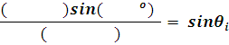(0. ) = cosD₁
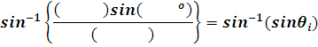cos⁻¹ (0. ) = cos⁻¹( cosD₁)
___________º = D₁
Sum Interior Angles of Triangle:
D₁ + D₂ + θ_{i} = 180º
Therefore: Pythagorean Theorem:
D₂ = ______º (d₃)² + (see diagram 1)² = (d₁)²
Pythagorean Theorem: ( )² + ( )² = (d₁)²
What right triangle could you use to find d₄? ( ) + ( ) = (d₁)²
(d₃)² + (see diagram 1)² = (d₄)² ( ) = (d₁)²
( ) = (d₁)²
____________ = d₁
____________ = d₄
Diagram 1F:
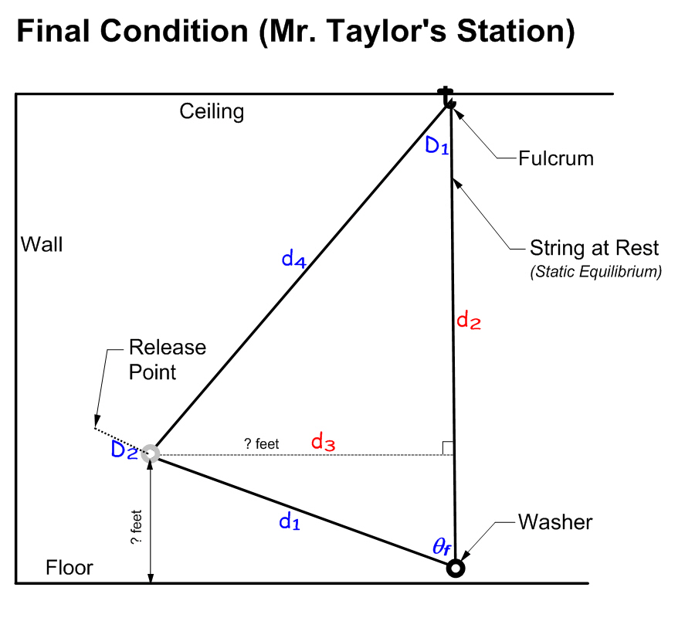
Diagram 1f Calculations:
Find the following - Calculated:
D₁=
d₄ =
Measured:
d₃ =
D₂ from floor=
Diagram 2:
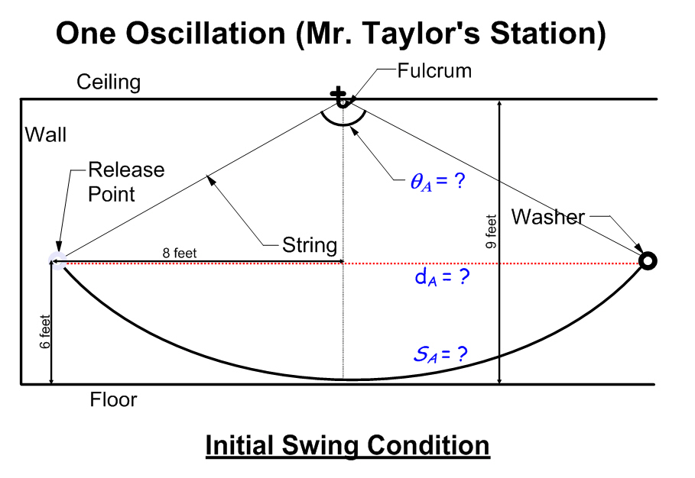
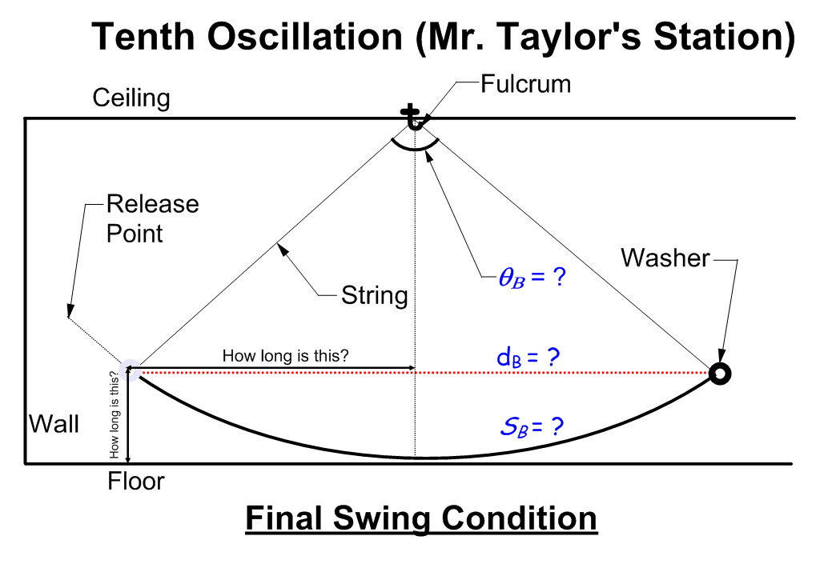

Diagram 2 Calculations: (Refer to diagram 1 calculations as necessary)
- Analyzing the One Oscillation Diagram
Calculate the chord length d_{A}
d_{A} = 2(measured-see diagram 2) = 2( ) = ______ inches
Compare your calculated dimension d₄ to your recorded tape measurement d₁
Percent Error (P.E.) = | (d₄ - d₁)/d₁ |(100)
P.E. = | ( - )/( ) | (100) = ________%
Using triangle data calculate the Central Angle (θ_{A}) or “angular displacement”
θ_{A} = 2(D₁) = 2( º) = _______º
Using θ_{A} calculate what percentage of the entire circle the sector you have described in this illustration might be?
θ_{A} /360º = ( º/360º)(100) = ___________%
Using the above information, and the circumference of a circle formula, how might you calculate the distance as captured by θ_{A} as an “arc length” (A.L.) which represents the true distance the pendulum actually travels from release point to its other extreme?
A.L. = ( %)(π)(2)(d₄) = (0. )(3.14)(2)( )
Arc Length_{A} (S_{A}) = ______ Inches
Using the above information, and the area of a circle formula, how might you calculate the “area of the sector” (A.S.) the pendulum motion describes as it moves through the angular displacement as shown by θ_{A}?
A.S. = ( %)(π)(d₄)² = (0. )(3.14)( )²
A.S. = (0. )(3.14)( ) = (0. )( )

Area of Sector_{A} (AS_{A}) = ______ Square Inches

(Refer to diagram 1f calculations as necessary)
- Analyzing the Tenth Oscillation Diagram
Calculate the chord length d_{B}
d_{B} = 2(see diagram 2) = 2( ) = ______ inches
Compare distance d_{A} to distance d_{B…}what is the difference between the two?
| d_{A} – d_{B} | = ________ inches
Using triangle data calculate the Central Angle (θ_{B}) or “angular displacement”
θ_{B} = 2(D₁) = 2( º) = _______º
Using θ_{B} calculate what percentage of the entire circle the sector you have described in this illustration might be?
θ_{B} /360º = ( º/360º)(100) = ___________%
Using the above information, and the circumference of a circle formula, how might you calculate the distance as captured by θ_{B} as an “arc length” (A.L.) which represents the true distance the pendulum actually travels from release point to its other extreme?
A.L. = ( %)(π)(2)(d₄) = (0. )(3.14)(2)( )
Arc Length_{B} (S_{B}) = ______ Inches
Using the above information, and the area of a circle formula, how might you calculate the “area of the sector” (A.S.) the pendulum motion describes as it moves through the angular displacement as shown by θ_{B}?
A.S. = ( %)(π)(d₄)² = (0. )(3.14)( )²
A.S. = (0. )(3.14)( ) = (0. )( )

Area of Sector_{B} (AS_{B}) = ______ Square Inches

Diagram 3:
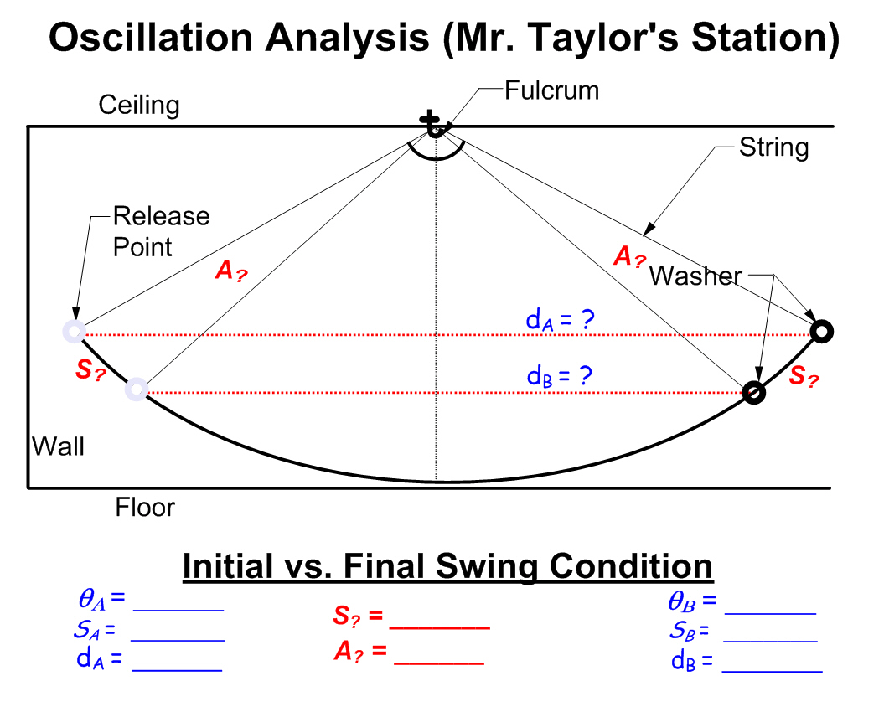
Fill in the values above from your previous calculations. Then find S? and A? using the following Trigonometric formulas: (Remember θ must be in radians to use these formulas)
AS_{A} = ______ AS_{B} = ______

If θ is in radians already:
S = rθ AS = (0.5)r²θ
If θ is in degrees and needs to be converted:
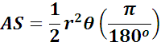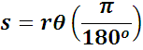

Think about what S? and A? are. What am I asking for? Create your calculation to find these values. Show all work on the following page. Original equations used, input values, steps, etc… Box your answers on calc sheet below then show answers in the spaces provided above.
Calculations Diagram 3:

Based upon your findings…Estimate how many oscillations from the original release point would be required for the pendulum to come to rest? (Return to static equilibrium)
_______________ full oscillations

Extension Bonus:
Create a graph as described below representing the values from Diagram 1 and using the initial swing condition in Diagram 2. Label all necessary values and attributes completely.
Graphical Representation:
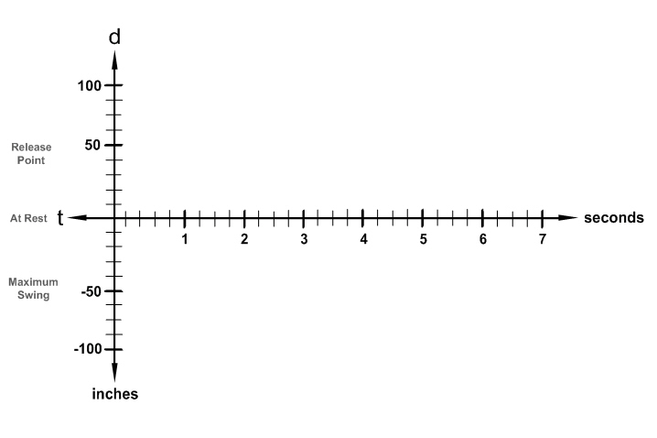
In the above graph we see the horizontal axis as time (t) is centered in the vertical axis such that if the pendulum is at rest it is represented as distance (d) zero, the full retraction of the weight to the release point is ______ inches positive (d) and when released it swings past the rest point, fully over to the other extreme position, that is represented by ______ inches negative (d).

