Graph the following. Label all positions on axis with the appropriate values and show work as necessary:

y = sin θ
Remember:
y = A sin kθ or y = A cos kθ
Calculate your Period here:

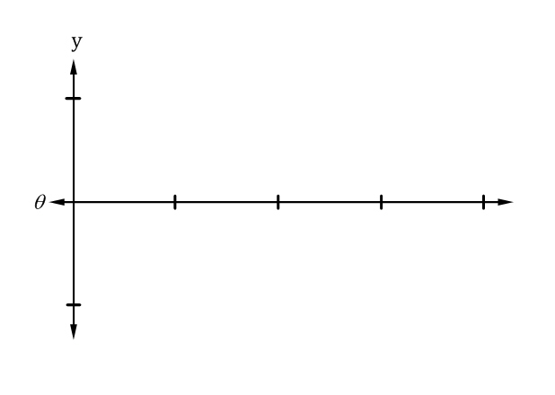

$P_{a}= \frac{2π}{k}$

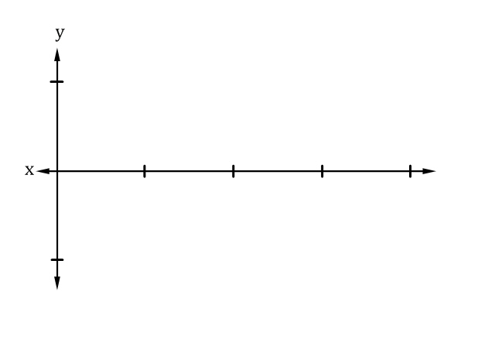
y = cos x
Remember:
y = A sin kθ or y = A cos kθ
Calculate your Period here:

$P_{a}= \frac{2π}{k}$

y = 2sin 4θ
Remember:
y = A sin kθ or y = A cos kθ
Calculate your Period here:

$P_{a}= \frac{2π}{k}$

y = 3cos $\frac{1}{2}$x
Remember:
y = A sin kθ or y = A cos kθ
Calculate your Period here:

$P_{a}= \frac{2π}{k}$

y = $\frac{2}{3}$sin $\frac{2θ}{3}$
Remember:
y = A sin kθ or y = A cos kθ
Calculate your Period here:

$P_{a}= \frac{2π}{k}$

y = -5cos 3πx
Remember:
y = A sin kθ or y = A cos kθ
Calculate your Period here:

$P_{a}= \frac{2π}{k}$

Graph the following trig functions over the given intervals:
$y=2sinx; -π≤x≤π$
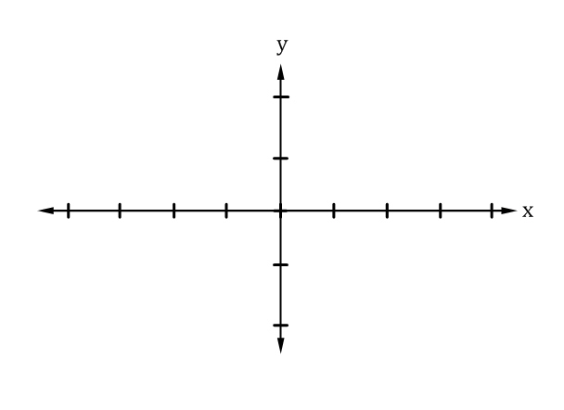
$y=cosx; -7π≤x≤-5π$

