Graph the following. Label all positions on axis with the appropriate values and show work as necessary:

y = 3sin θ
Remember:
y = A sin (kθ − h) + v_{s}
y = A cos (kθ − h) + v_{s}

Calculate your Period here:

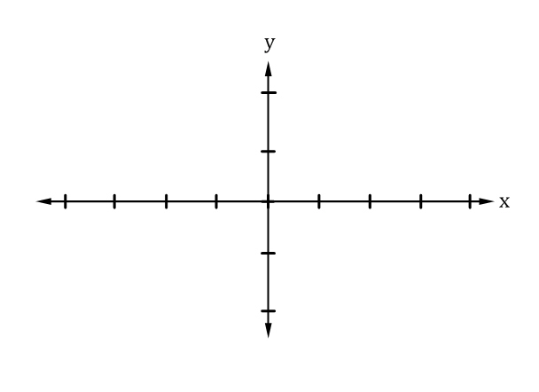

$P_{a}= \frac{2π}{k} and h_{s}= \frac{-h}{k}$

θ

y = 2cos x
Remember:
y = A sin (kθ − h) + v_{s}
y = A cos (kθ − h) + v_{s}

Calculate your Period here:

$P_{a}= \frac{2π}{k} and h_{s}= \frac{-h}{k}$

y = tan θ
Remember:
y = A sin (kθ − h) + v_{s}
y = A cos (kθ − h) + v_{s}

Calculate your Period here:

$P_{a}= \frac{π}{k} and h_{s}= \frac{-h}{k}$

θ

y = cot x
Remember:
y = A sin (kθ − h) + v_{s}
y = A cos (kθ − h) + v_{s}

Calculate your Period here:

$P_{a}= \frac{π}{k} and h_{s}= \frac{-h}{k}$

y = 4sec 2θ
Remember:
y = A sin (kθ − h) + v_{s}
y = A cos (kθ − h) + v_{s}

Calculate your Period here:

$P_{a}= \frac{2π}{k} and h_{s}= \frac{-h}{k}$

θ

y = 2csc 4x
Remember:
y = A sin (kθ − h) + v_{s}
y = A cos (kθ − h) + v_{s}

Calculate your Period here:

$P_{a}= \frac{2π}{k} and h_{s}= \frac{-h}{k}$

$$y=2\sin{(2θ+\frac{π}{2}})+2$$
Remember:
y = A sin (kθ − h) + v_{s}
y = A cos (kθ − h) + v_{s}

Calculate your Period here:

$P_{a}= \frac{2π}{k} and h_{s}= \frac{-h}{k}$

θ

$$y=-3\cos{(4θ-\frac{π}{3}})-2$$
Remember:
y = A sin (kθ − h) + v_{s}
y = A cos (kθ − h) + v_{s}

Calculate your Period here:

$P_{a}= \frac{2π}{k} and h_{s}= \frac{-h}{k}$

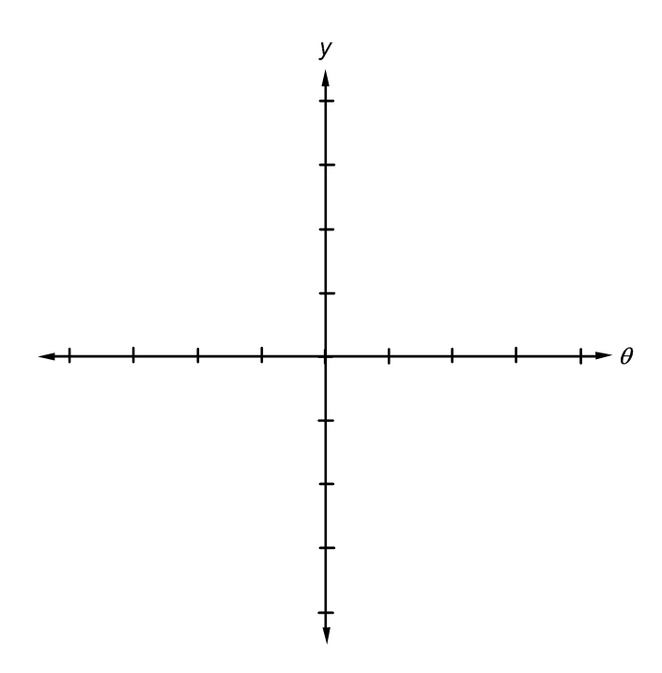
y = sin⁻¹ θ
Remember:
y = A sin (kθ − h) + v_{s}
y = A cos (kθ − h) + v_{s}

Calculate your Period here:

$P_{a}= \frac{2π}{k} and h_{s}= \frac{-h}{k}$

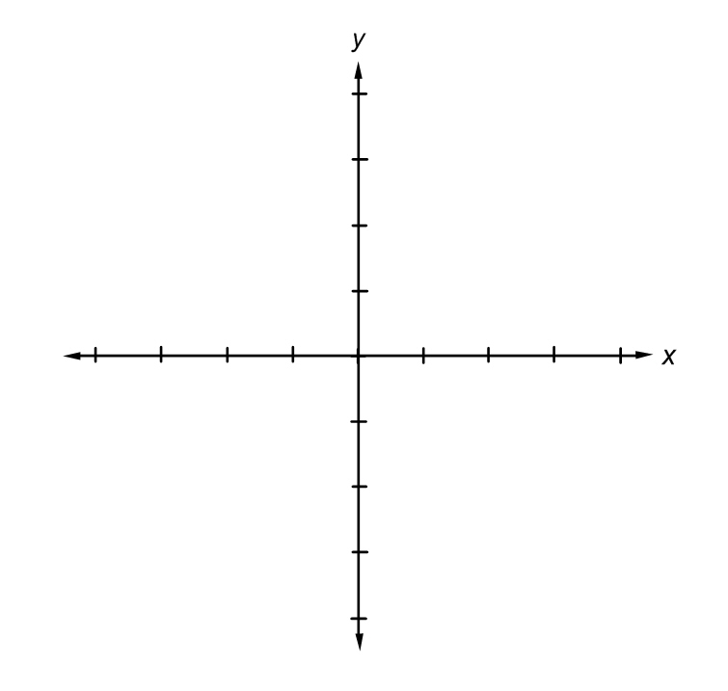
y = cos⁻¹ x
Remember:
y = A sin (kθ − h) + v_{s}
y = A cos (kθ − h) + v_{s}

Calculate your Period here:

$P_{a}= \frac{2π}{k} and h_{s}= \frac{-h}{k}$

y = tan⁻¹ θ
Remember:
y = A sin (kθ − h) + v_{s}
y = A cos (kθ − h) + v_{s}

Calculate your Period here:

$P_{a}= \frac{π}{k} and h_{s}= \frac{-h}{k}$

y = cot⁻¹ x
Remember:
y = A sin (kθ − h) + v_{s}
y = A cos (kθ − h) + v_{s}

Calculate your Period here:

$P_{a}= \frac{π}{k} and h_{s}= \frac{-h}{k}$

y = sec⁻¹ θ
Remember:
y = A sin (kθ − h) + v_{s}
y = A cos (kθ − h) + v_{s}

Calculate your Period here:

$P_{a}= \frac{2π}{k} and h_{s}= \frac{-h}{k}$

y = csc⁻¹ x
Remember:
y = A sin (kθ − h) + v_{s}
y = A cos (kθ − h) + v_{s}

Calculate your Period here:

$P_{a}= \frac{2π}{k} and h_{s}= \frac{-h}{k}$

Solve the following as directed…Show ALL work:
Solve for x:
- x = sin⁻¹(0)

- sin⁻¹ (tan $\frac{π}{3}$)

- Determine the Angular Velocity if 26 revolutions are completed in 40 seconds?

- Given a central angle of $\frac{2π}{3}$, find the length of its intercepted arc in a circle of radius of 10 inches…show your answer in terms of pi (no calculator required)

- Convert 210 degrees in to radians ( no calculator required)

- The initial behavior of the note “E” above “middle C” can be modeled y = 0.5 sin 660πt
  - What is the amplitude in this model?

  - What is the period this model?

  - Find the frequency (cycles per second) of this note

