Graph the following. Label all positions on axis with the appropriate values and show work as necessary:

y = sin θ
Remember:
y = A sin (kθ − h) + v_{s}
y = A cos (kθ − h) + v_{s}

Calculate your Period here:

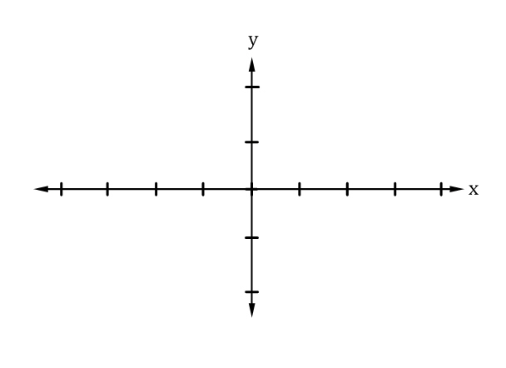

$P_{a}= \frac{2π}{k} and h_{s}= \frac{-h}{k}$

θ

y = cos x
Remember:
y = A sin (kθ − h) + v_{s}
y = A cos (kθ − h) + v_{s}

Calculate your Period here:

$P_{a}= \frac{2π}{k} and h_{s}= \frac{-h}{k}$

y = tan θ
Remember:
y = A sin (kθ − h) + v_{s}
y = A cos (kθ − h) + v_{s}

Calculate your Period here:

$P_{a}= \frac{π}{k} and h_{s}= \frac{-h}{k}$

θ

y = cot x
Remember:
y = A sin (kθ − h) + v_{s}
y = A cos (kθ − h) + v_{s}

Calculate your Period here:

$P_{a}= \frac{π}{k} and h_{s}= \frac{-h}{k}$

y = sec θ
Remember:
y = A sin (kθ − h) + v_{s}
y = A cos (kθ − h) + v_{s}

Calculate your Period here:

$P_{a}= \frac{2π}{k} and h_{s}= \frac{-h}{k}$

θ

y = csc x
Remember:
y = A sin (kθ − h) + v_{s}
y = A cos (kθ − h) + v_{s}

Calculate your Period here:

$P_{a}= \frac{2π}{k} and h_{s}= \frac{-h}{k}$

$$y=2\sin{(2θ-\frac{π}{2}})+2$$
Remember:
y = A sin (kθ − h) + v_{s}
y = A cos (kθ − h) + v_{s}

Calculate your Period here:

$P_{a}= \frac{2π}{k} and h_{s}= \frac{-h}{k}$

θ

$$y=-3\cos{(4θ+\frac{π}{3}})-2$$
Remember:
y = A sin (kθ − h) + v_{s}
y = A cos (kθ − h) + v_{s}

Calculate your Period here:

$P_{a}= \frac{2π}{k} and h_{s}= \frac{-h}{k}$

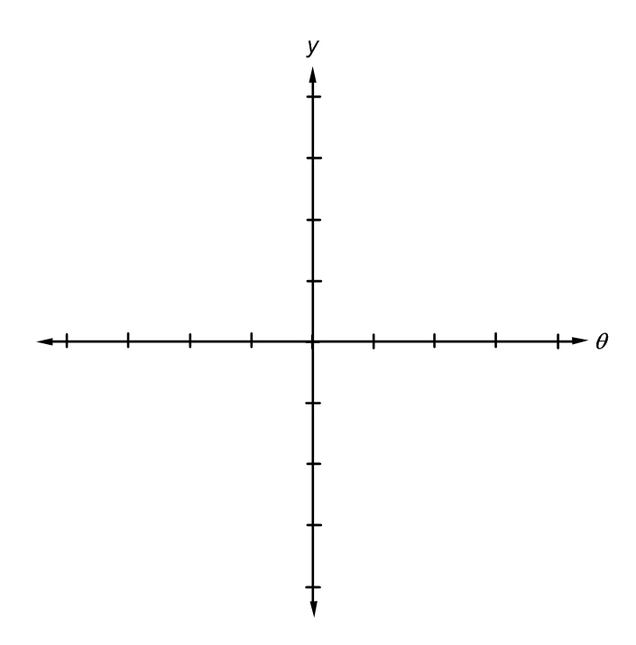
y = sin⁻¹ θ
Remember:
y = A sin (kθ − h) + v_{s}
y = A cos (kθ − h) + v_{s}

Calculate your Period here:

$P_{a}= \frac{2π}{k} and h_{s}= \frac{-h}{k}$

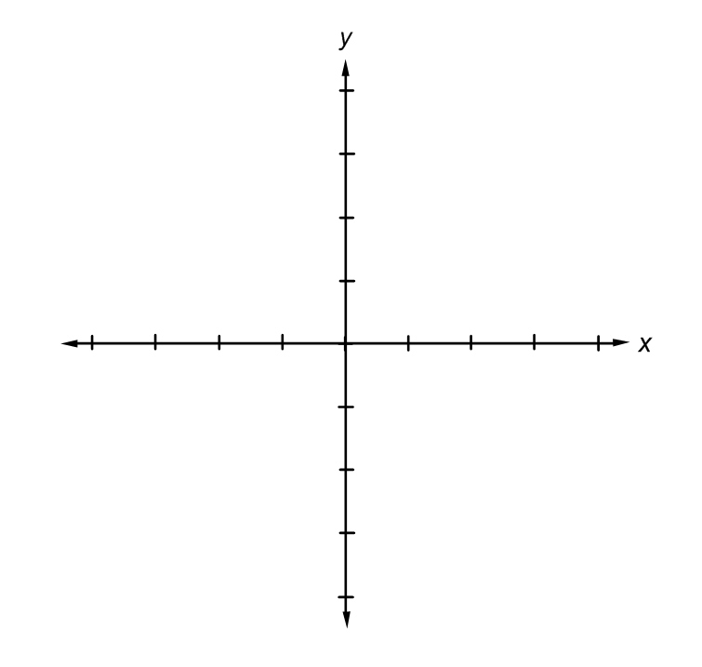
y = cos⁻¹ x
Remember:
y = A sin (kθ − h) + v_{s}
y = A cos (kθ − h) + v_{s}

Calculate your Period here:

$P_{a}= \frac{2π}{k} and h_{s}= \frac{-h}{k}$

y = tan⁻¹ θ
Remember:
y = A sin (kθ − h) + v_{s}
y = A cos (kθ − h) + v_{s}

Calculate your Period here:

$P_{a}= \frac{π}{k} and h_{s}= \frac{-h}{k}$

y = cot⁻¹ x
Remember:
y = A sin (kθ − h) + v_{s}
y = A cos (kθ − h) + v_{s}

Calculate your Period here:

$P_{a}= \frac{π}{k} and h_{s}= \frac{-h}{k}$

y = sec⁻¹ θ
Remember:
y = A sin (kθ − h) + v_{s}
y = A cos (kθ − h) + v_{s}

Calculate your Period here:

$P_{a}= \frac{2π}{k} and h_{s}= \frac{-h}{k}$

y = csc⁻¹ x
Remember:
y = A sin (kθ − h) + v_{s}
y = A cos (kθ − h) + v_{s}

Calculate your Period here:

$P_{a}= \frac{2π}{k} and h_{s}= \frac{-h}{k}$

