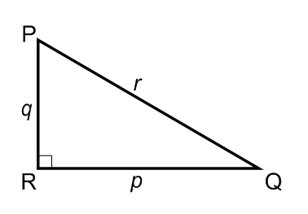
Using the triangle to the right solve for the following:
1)
<Q = 42º
p = 24
r = ?

2)
<Q = 42º
p = 24
q = ?

3)
<P = 68º
q = 54
r = ?

4)
<Q = 30º
p = 40
r = ?

5)
<P = 53º
p = 23
q = ?

6)
<Q = 20º
p = 110
q = ?

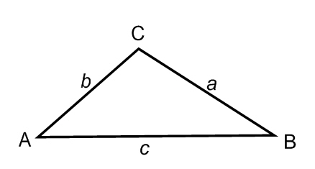
Given the following triangle and formula for the law of sines: $\frac{a}{\sin{A}}= \frac{b}{\sin{B}}= \frac{c}{\sin{C}}$
Solve for the following as directed:
7)
<A = 50º
<C =115º
c = 22
a = ?

8)
<A = 50º
<C =115º
c = 22
Solve the triangle:

9)
<A = 35º
<C =95º
a = 22
Solve the triangle:

10)
<A = 75º
<C =75º
b = 25
Solve the triangle:

11)
<A = 55º
a =15
b = 35
Solve the triangle:

12)
<C = 45º
a =14
c = 36
Solve the triangle:

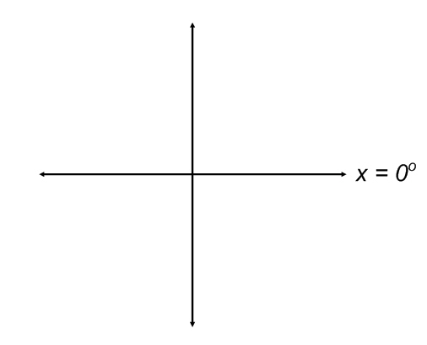
Use the unit Circle axis to sketch a graph of x and find the reference triangle:
13) x = 45º
Find:
sinx =
cosx =
tanx =

14) x = 120º
Find:
sinx =
cosx =
tanx =

15) x = -60º
Find:
sinx =
cosx =
tanx =
16) x = 240º
Find:
sinx =
cosx =
tanx =

17) x = 315º
Find:
sinx =
cosx =
tanx =

18) x = -120º
Find:
sinx =
cosx =
tanx =

19) x = 930º
Find:
sinx =
cosx =
tanx =

20) x = -510º
Find:
sinx =
cosx =
tanx =

Bonus:
Find the value of the following:
21) $cos⁡\left(\sec^{-1} \frac{3}{5}\right)$ 22) $csc⁡\left(\sin^{-1} \frac{3}{5}\right)$ 23) $cos⁡\left(\sin^{-1} \frac{3}{5}\right)$

Find the Area of the following triangles:
24) <A = 28º
b = 14 $Area= \frac{1}{2}\left(s_{1}\right)\left(s_{2}\right)sin(<_{3})$
c = 9

25) <A = 54º
<C = 65º
a = 19.2

Use the Law of Cosine to solve for each triangle: $a^{2}=b^{2}+c^{2}-2bccosA$
26) <C = 120º
a = 9
b = 5

