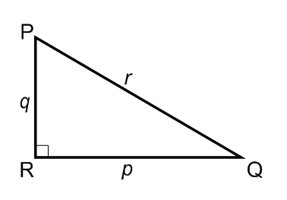
Using the triangle to the right solve for the following:
1)
<Q = 22º
p = 14
r = ?

2)
<Q = 22º 14’
p = 14.5
q = ?

3)
<P = 68º 30’ 30”
q = 14.9
r = ?

Joe
Using the triangle to the right to solve for the following:
4)
<Q = 30º
p = 20.75
r = ?

5)
<P = 55.595º
p = 20.22
q = ?

6)
<Q = 10º 10’ 10”
p = 120
q = ?

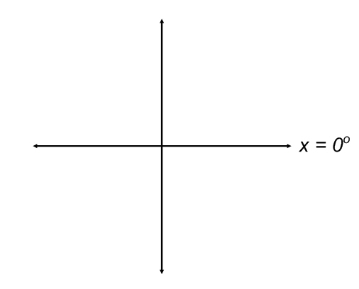
Use the unit circle axis to sketch a graph of x and find the reference triangle to solve the following:
Joe
7) x = 45º
Find:
sinx =
cosx =
tanx =

8) x = 120º
Find:
sinx =
cosx =
tanx =

9) x = - 60º
Find:
sinx =
cosx =
tanx =

10) x = 240º
Joe
Find:
sinx =
cosx =
tanx =

11) x = 315º
Find:
sinx =
cosx =
tanx =

12) x = -120º
Find:
sinx =
cosx =
tanx =

Joe

