- Y varies directly as X. When Y = 2, X = 10…

Find k:

- The amount of money raised at a charity fundraiser is directly proportional to the number of attendees. The amount of money raised for five attendees was $100. How much money will be raised for 60 attendees?

- Y varies linearly with X. When X = 0, Y = 5. When
X = 3, Y = 11. Find the entire equation.

- Y varies linearly with X.
When X = 2, Y = 15.
When X = 4, Y = 23.
Find k:

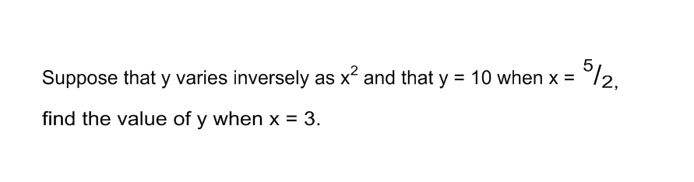

5.
- H

- Suppose that y varies inversely as x and that y = 8 when x = 3.

  - Form an equation connecting x and y.

  - Calculate the value of y when x = 10.

- Carl drove from his house to work at an average speed of 35 miles per hour. The drive took him 25 minutes. If the drive home took him 30 minutes and he used the same route in reverse, what was his average speed going home?

- The force needed to keep a car from skidding on a curve varies jointly as the weight of the car and the square of the speed, and inversely as the radius of the curve. It takes 3800 pounds of force to keep an 1800 pound car from skidding on a curve with radius 425 feet at a speed of 45 mph.

What force is needed to keep the same car from skidding when it takes a similar curve with radius 450 feet at 55 mph?

- z varies jointly as x and y, inversely as w. Write appropriate combined variation equation and find z for given values x, y, and w.

z = 10 when x = 5 and w = 3

when x = 8, y = 6 and w = -12, z = ?

- Bob's dentist determined the number of cavities developed in his patient's mouth each year is inversely proportional to the total number of minutes spent brushing during each session. If Bob developed four cavities during the year in which he spent only 30 seconds brushing his teeth each time, how many annual cavities will Bob develop if he increases his brushing time to two minutes per session?

Reflection and Extension:

How do you feel about these types of problems? How does the strategy you use to solve these types of problems relate to chemical mixture or percent composition problems?

CHALLENGE Problems:

Q varies as the cube root of Z. If Q=9 and Z=27, find

1. The constant of proportionality

2. An expression for Z in terms of Q

3. The value of Q when Z=8

The gravitational force F between two spherical objects, having mass m₁ and m₂ respectively, varies jointly with respect to m₁ and m₂ and inversely with respect to the square of the distance d between the two objects. If m₁ = 20 kilograms, m₂ = 100 kilograms and the force F = 3.35x10⁸ Newtons when the distance between the two objects is d = 2 meters, find the constant of proportionality.

